**Conceptual Design Report**

Chaser Group 2

Rachel VanRyzin and Isabella Knox

We have adhered to the Duke Community Standard in completing this assignment.

*Introduction*

The goal of the project is to produce a quidditch team of five robots which will sense obstacles and communicate with one another to determine and display the score that the team would have scored from quaffle goals and possibly catching the golden snitch. To achieve this goal, the chasers must detect ramps or quaffles, and communicate with their paired beater, which must sense RFID tags or red and green signs, respectively. The chasers and beaters must also communicate their scores to the seeker bot, which detects the number of mirrors on its line and drives to the corresponding line in an attempt to catch the snitch (150 additional points). All bots must be able to sense and follow lines so that they can stay in their lanes, as well as communicate with every other bot so that every bot can display the team’s final score. Specifically, Chaser 2’s bot must sense the presence of red quaffles and communicate with Beater 2 (which senses red and green signs) to determine whether or not the team would score 10 points at each hash mark.

*Planning and Management*

Gantt Chart with Task Assignments

The Gantt Chart and tasks were split into IDC phases. Under each phase were the relating tasks for that IDC. The tasks were often split into either a weekly update, coding or integrating of sensors for the personal bot, demonstrations, or team bot tasks (such as team communication, point display, and information sending/receiving). The planned dates (planned starts and due dates) were also added along each individual task and the IDC phases with the progress percentage. The workload in order to help track progress and time management were also added. Each IDC phase has 5-7 tasks underneath, but extra tasks that are seen as needed to be added as the IDC project progresses can be added. The blue highlighted cells are the expected timeline for each task, and the dash marks in each cell represent the completion of the task. Since the base robot kit we are using for this project (as found off of <https://www.parallax.com/product/32335>) is $199.00, the communication gear costs $24.47, and the two sensors we will test are the IR LED with cover and IR receiver (together) and the whisker wires (along with materials needed to attach them) will cost around $11.19, the total cost estimate for the finished bot at this time is around $234.66.

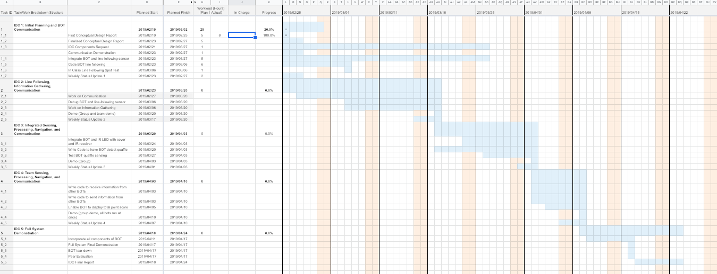

*Trade Study*

1. Goal/Problem to Solve: The Chaser 2 bot must be able to identify the presence of red quaffles on hash marks along its line.

2. Possible Solutions:

* ColorPAL sensor (to detect the red color of the quaffle)
* IR LED with cover and IR receiver (to detect that a large obstacle is in the robot’s path)
* Whisker wires (to let the bot feel when it has touched an obstacle)
* Phototransistor (if mounted low on the robot, could be triggered to go off when it is in the shadow of the quaffle, where there is less ambient light)

3. Solution Judgement Criteria:

* Reliability (How often does it sense when it is supposed to?)
* Cost (Is it expensive?)
* Space taken up on the front of the bot (Is it better there a better use of real estate than this sensor, such as two of the other sensors together?)
* Durability (if the sensor gets bumped, will it cease to do its job?)
* Potential for Collaboration (will other groups be using this sensor? Can we collaborate to make the sensor as effective as possible?)

4. Criteria Values for Each Solution

|  |  |  |  |  |  |
| --- | --- | --- | --- | --- | --- |
|  | **Reliability (% of the time it works)** | **Cost** | **Space Needed (% of the front of the bot)** | **Durability** | **Collaboration Potential** |
| **ColorPAL Sensor** | ~55 | $29.99 | ~5 | Will very Rarely need adjusted | Definitely can collaborate with Beater 2 |
| **IR LED with cover and IR receiver (together)** | ~85 | $5.39 | ~15 | Will need to adjust every time it is pulled from the box (mounted on wires) | Likely can collaborate with Chaser 1, Beater 2, and Seeker |
| **Whisker Wires (pair)** | ~85 | $3.00 | ~8 | Will rarely need adjusted | Likely could collaborate with Beater 2 and Seeker |
| **Phototransistor** | ~15 | $1.49 | ~5 | Will need to adjust every time it is pulled from the box (mounted on wires) | Definitely could collaborate with Seeker |

5. Normalized Scale for Each Factor

|  |  |  |  |  |  |  |  |  |  |  |
| --- | --- | --- | --- | --- | --- | --- | --- | --- | --- | --- |
|  | **10** | **9** | **8** | **7** | **6** | **5** | **4** | **3** | **2** | **1** |
| **Reliability (% of the time it works)** | 90-100 | 80-90 | 70-80 | 60-70 | 50-60 | 40-50 | 30-40 | 20-30 | 10-20 | 0-10 |
| **Cost ($)** | 0-3 | 3-6 | 6-9 | 9-12 | 12-15 | 15-18 | 18-21 | 21-24 | 24-27 | 27-30 |
| **Space Needed (% of bot front)** | 0-10 | 10-20 | 20-30 | 30-40 | 40-50 | 50-60 | 60-70% | 70-80 | 80-90 | 90-100 |
| **Durability** | Never needs adjusting | Very Rarely needs adjusting | Rarely needs adjusting | Sometimes needs to be fixed | Needs fixing every other lab day | Needs fixing when removed from the box | Needs fixing often | Needs fixing quite often | Needs adjusted once per demo | Needs to be fixed after each obstacle |
| **Collaboration Potential** | Can definitely collab with 4 groups | Can likely collab with 4 groups | Can definitely collab with 3 groups | Can likely collab with 3 groups | Can definitely collab with 2 groups | Can likely collab with 2 groups | Can definitely collab with 1 group | Can likely collab with 1 group | Likely cannot collab with anyone | Definitely cannot collab with anyone |

6. Weighting Factor and Reasoning

|  |  |  |
| --- | --- | --- |
|  | **Multiplication Factor** | **Rationale** |
| **Reliability** | 4 | Grade depends on accurate sensing |
| **Space Needed** | 1 | It’s okay for the bot to look messy, as long as all the necessary components fit |
| **Cost** | 1 | Duke has a multi-billion dollar endowment |
| **Durability** | 3 | If the bot keeps breaking in different areas, it will be challenging to troubleshoot before every demo |
| **Collaboration Potential** | 2 | The more minds that are put to the task, the more efficient and foolproof the sensing strategy can be |

7. Total Value for Each Solution

|  |  |  |  |  |  |  |  |  |  |
| --- | --- | --- | --- | --- | --- | --- | --- | --- | --- |
|  |  | **ColorPAL Sensor** | | **IR LED with cover and IR receiver (together)** | | **Whisker Wires (pair)** | | **Phototransistor** | |
|  | Weight Factor | Norm. Value | Total | Norm. Value | Total | Norm. Value | Total | Norm. Value | Total |
| Reliability | 4 | 6 | 24 | 9 | 36 | 9 | 36 | 2 | 8 |
| Space Needed | 1 | 10 | 10 | 9 | 9 | 10 | 10 | 10 | 10 |
| Cost | 1 | 3 | 3 | 9 | 9 | 10 | 10 | 10 | 10 |
| Durability | 3 | 9 | 27 | 5 | 15 | 8 | 24 | 5 | 15 |
| Collab Potential | 2 | 4 | 8 | 7 | 14 | 5 | 10 | 4 | 8 |
| Grand Total |  |  | 72 |  | 83 |  | 69 |  | 51 |

